# 1.按员工编号升序排列不在10号部门工作的员工信息

SELECT * FROM emp WHERE deptno <> 10 ORDER BY empno ASC;

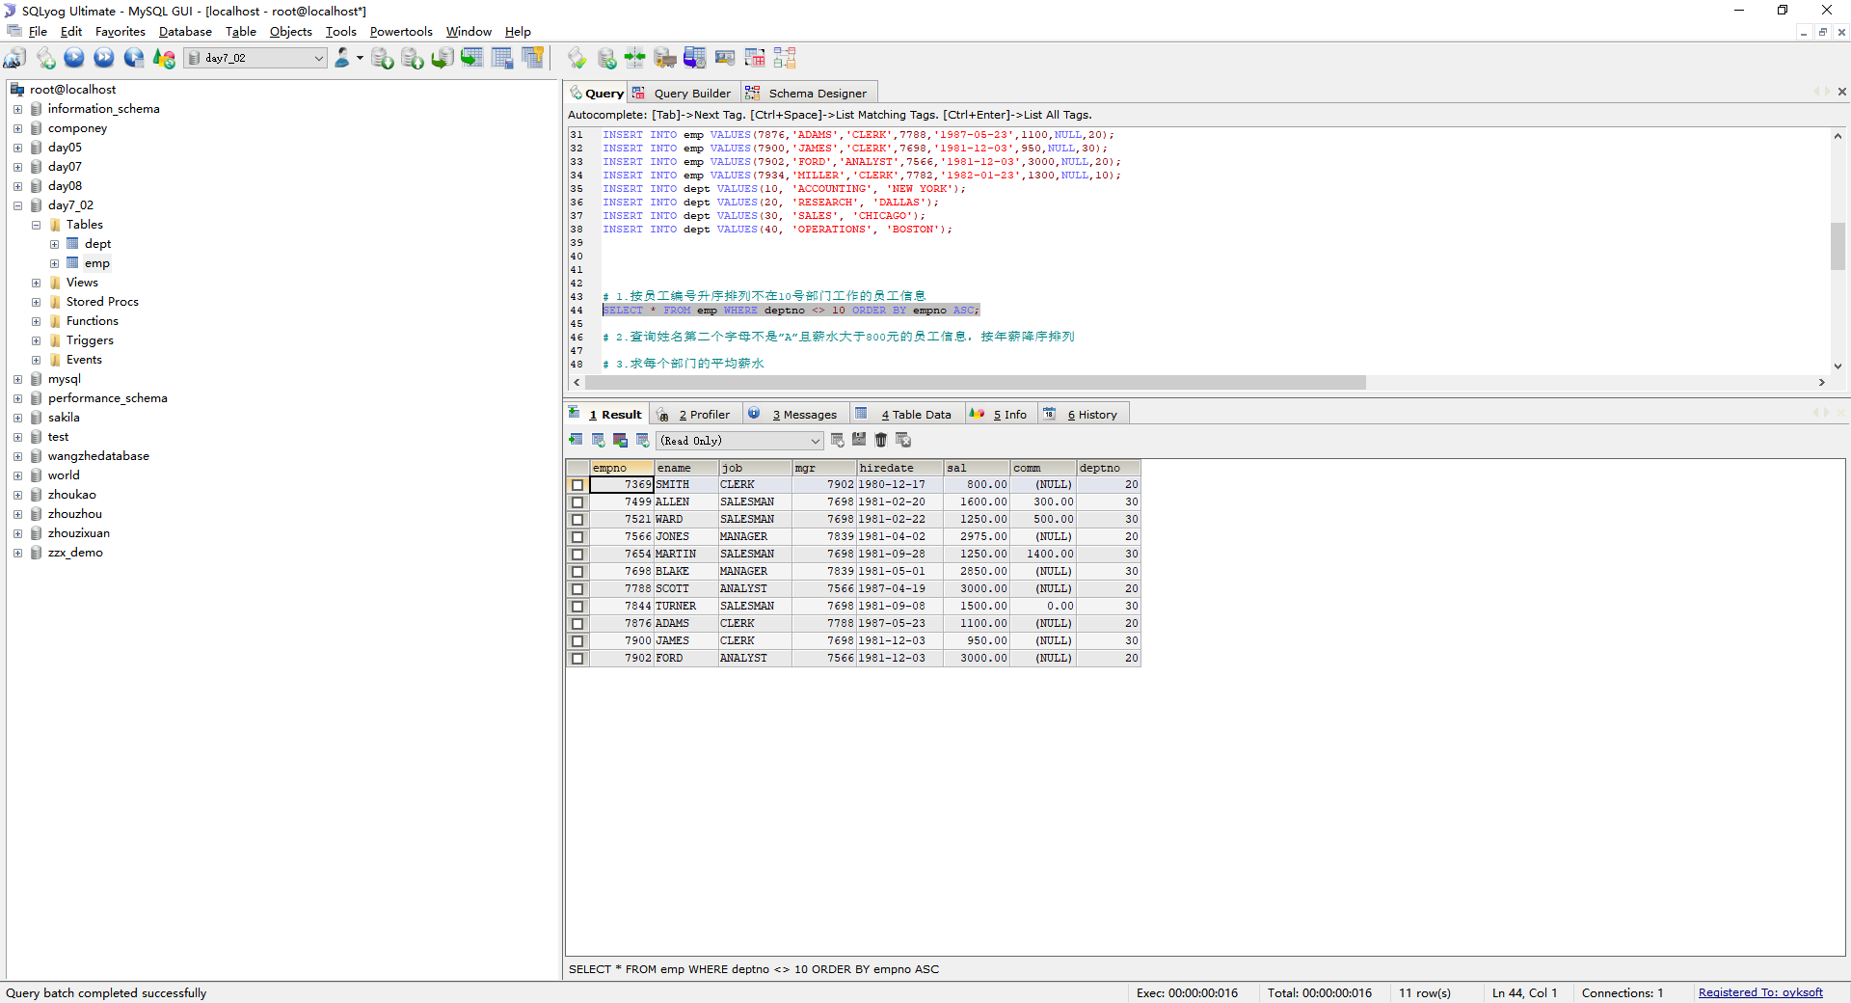

# 2.查询姓名第二个字母不是”A”且薪水大于800元的员工信息，按年薪降序排列

SELECT * FROM emp WHERE ename NOT LIKE '_A%' AND sal > 800 ORDER BY sal*12 DESC;

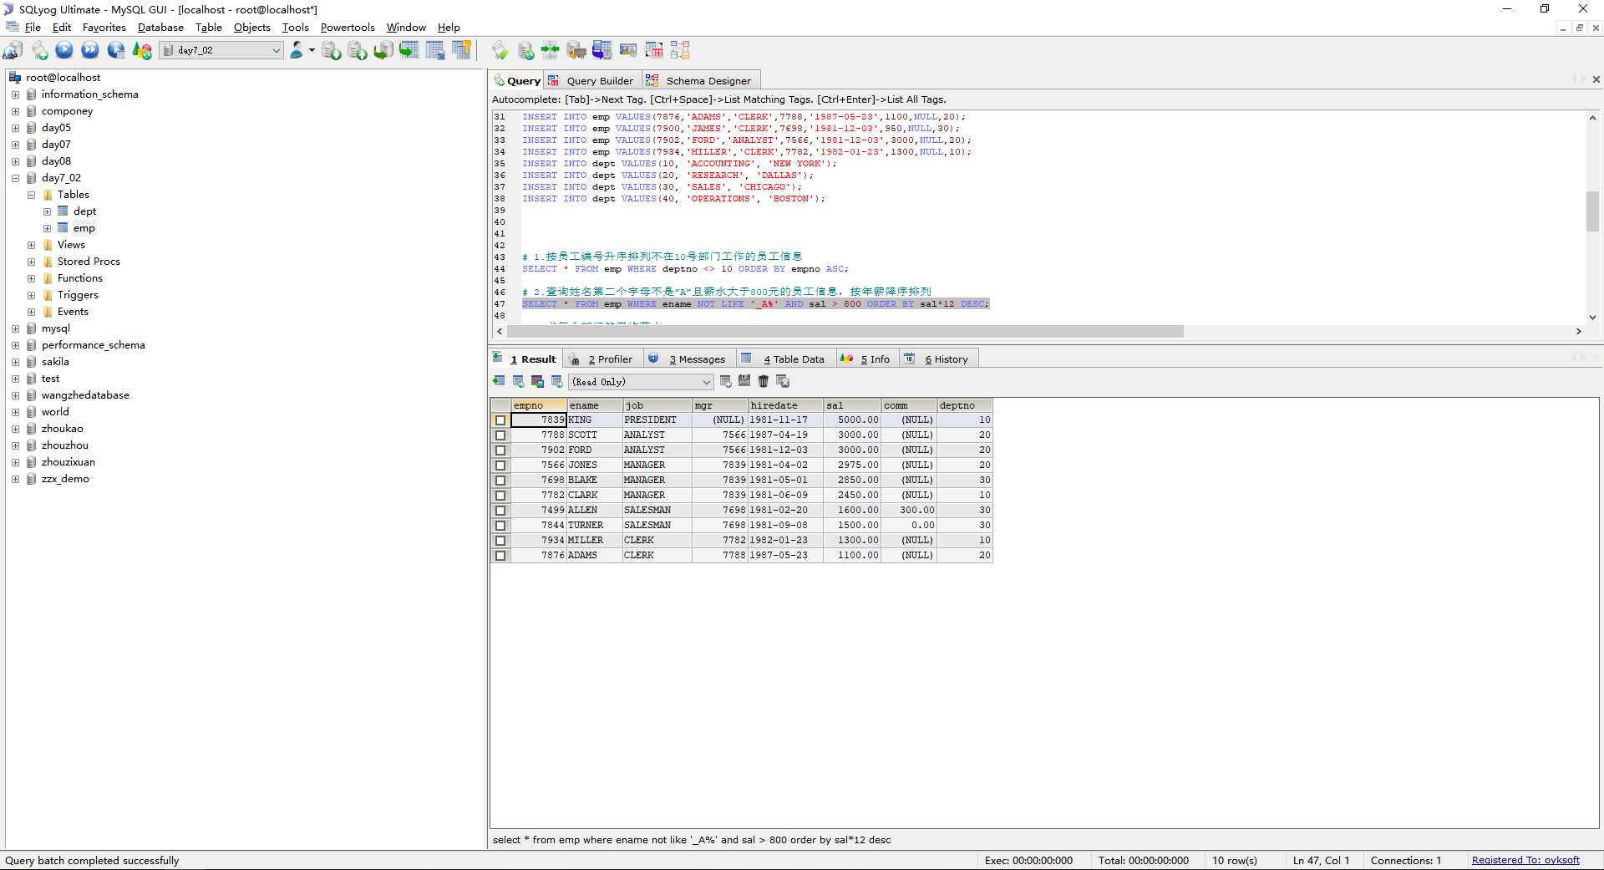

# 3.求每个部门的平均薪水

SELECT deptno,AVG(sal) FROM emp GROUP BY deptno;

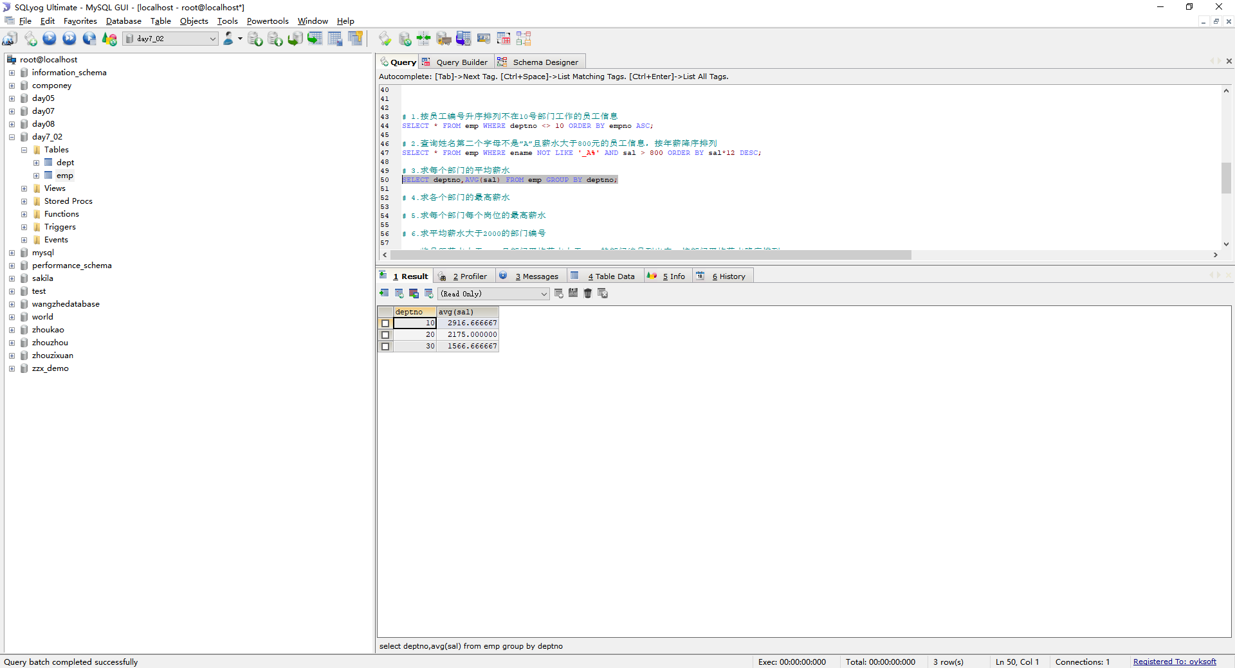

# 4.求各个部门的最高薪水

SELECT deptno,MAX(sal) FROM emp GROUP BY deptno;

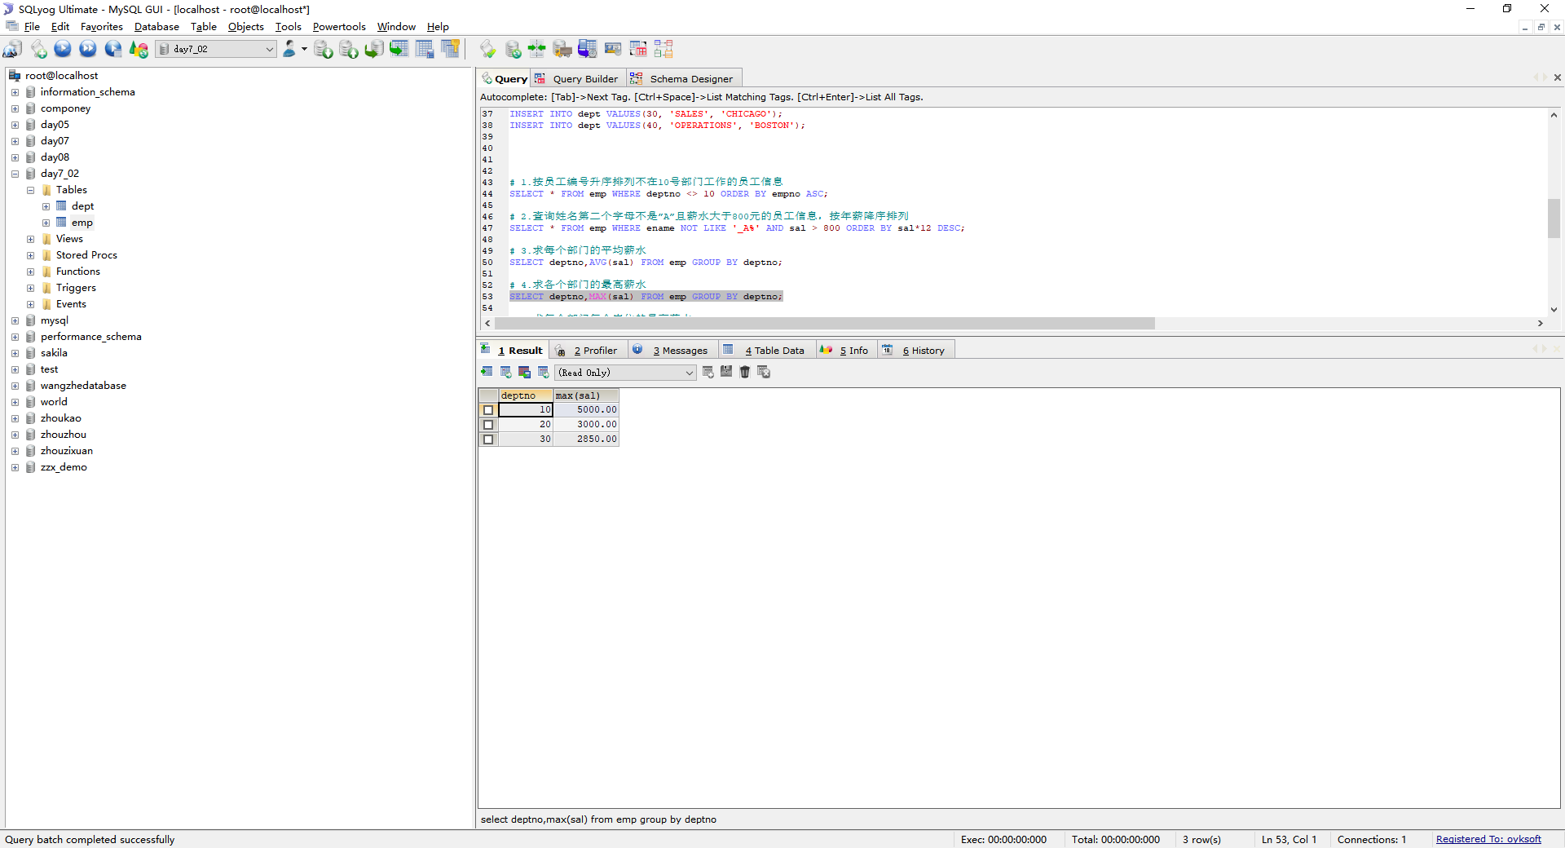

# 5.求每个部门每个岗位的最高薪水

SELECT deptno,job,MAX(sal) FROM emp GROUP BY deptno,job;

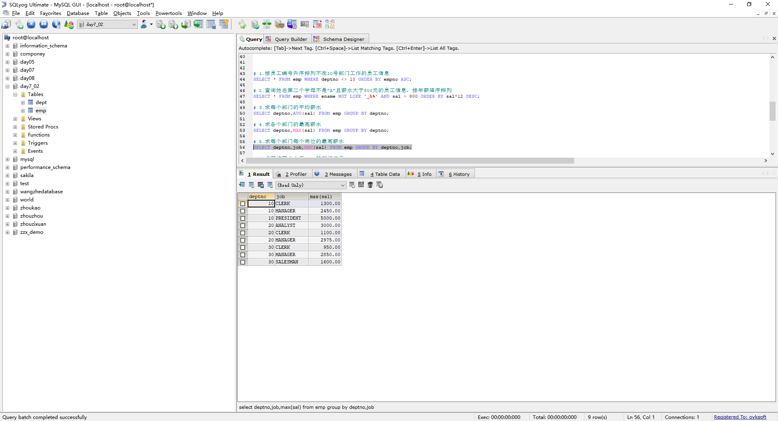

# 6.求平均薪水大于2000的部门编号

SELECT deptno,AVG(sal) FROM emp GROUP BY deptno HAVING AVG(sal) > 2000;

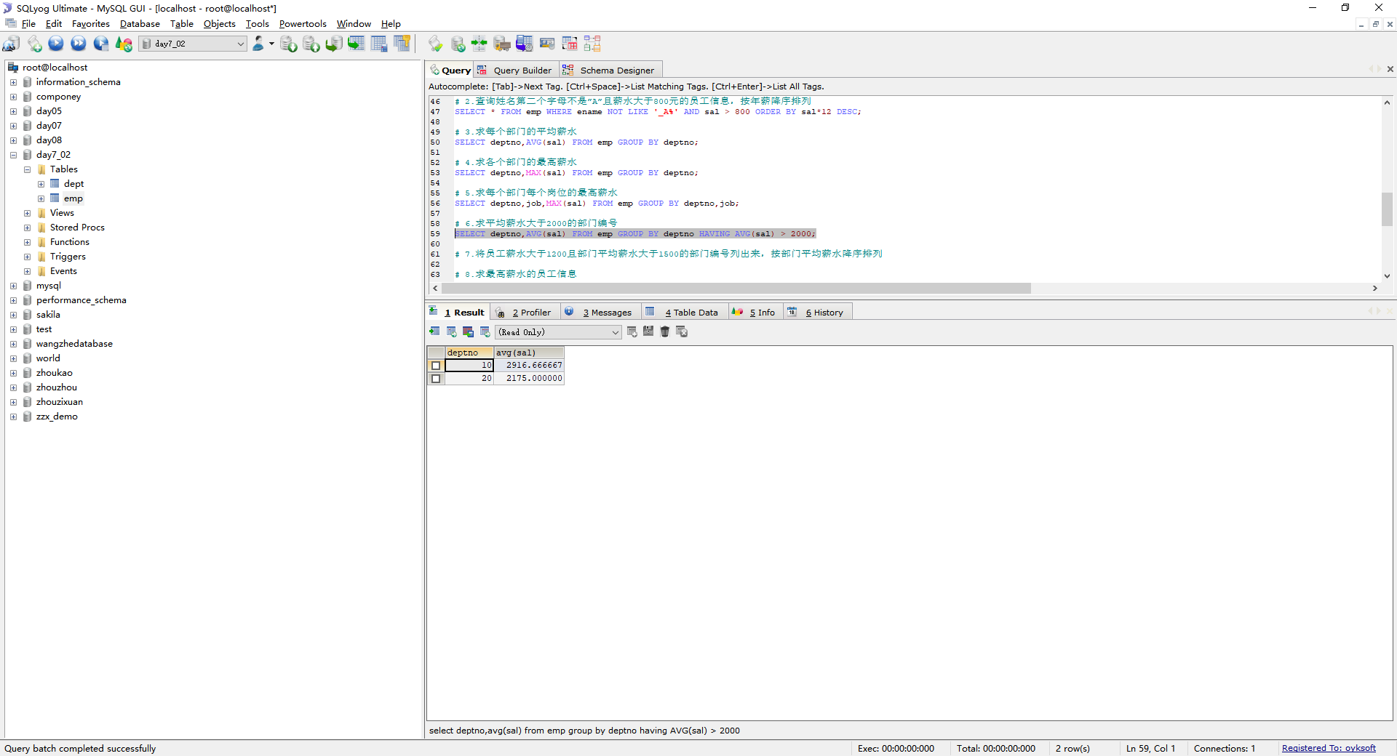

# 7.将员工薪水大于1200且部门平均薪水大于1500的部门编号列出来，按部门平均薪水降序排列

SELECT empno,deptno,AVG(sal) FROM emp WHERE sal> 1200 GROUP BY deptno HAVING AVG(sal)> 1500 ORDER BY AVG(sal) DESC;

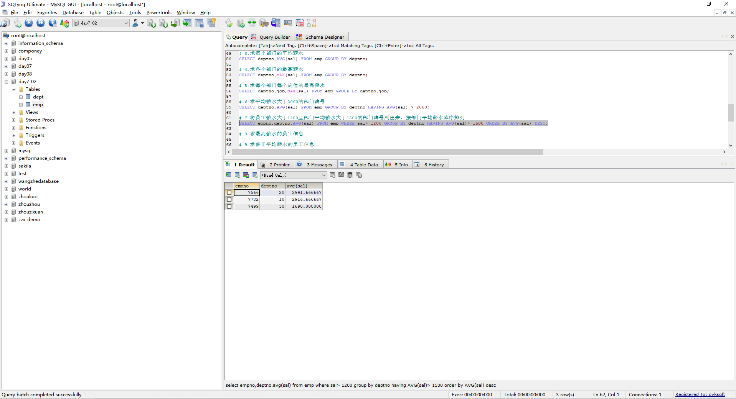

# 8.求最高薪水的员工信息

SELECT * FROM emp WHERE sal = (SELECT MAX(sal) FROM emp);

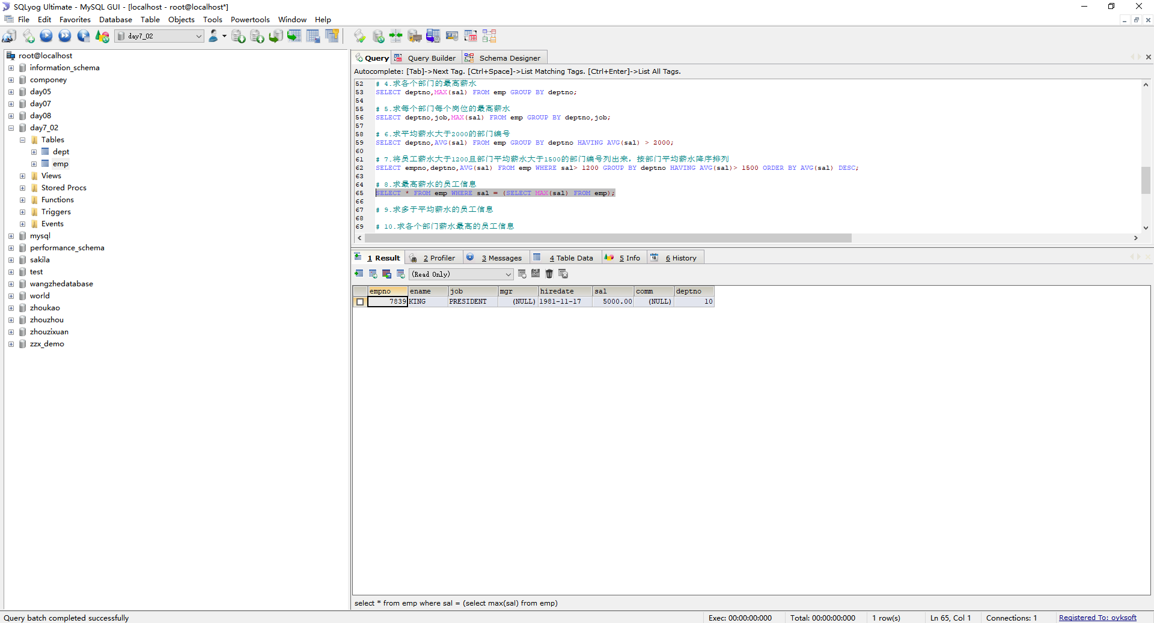

# 9.求多于平均薪水的员工信息

SELECT * FROM emp WHERE sal > (SELECT AVG(sal) FROM emp);

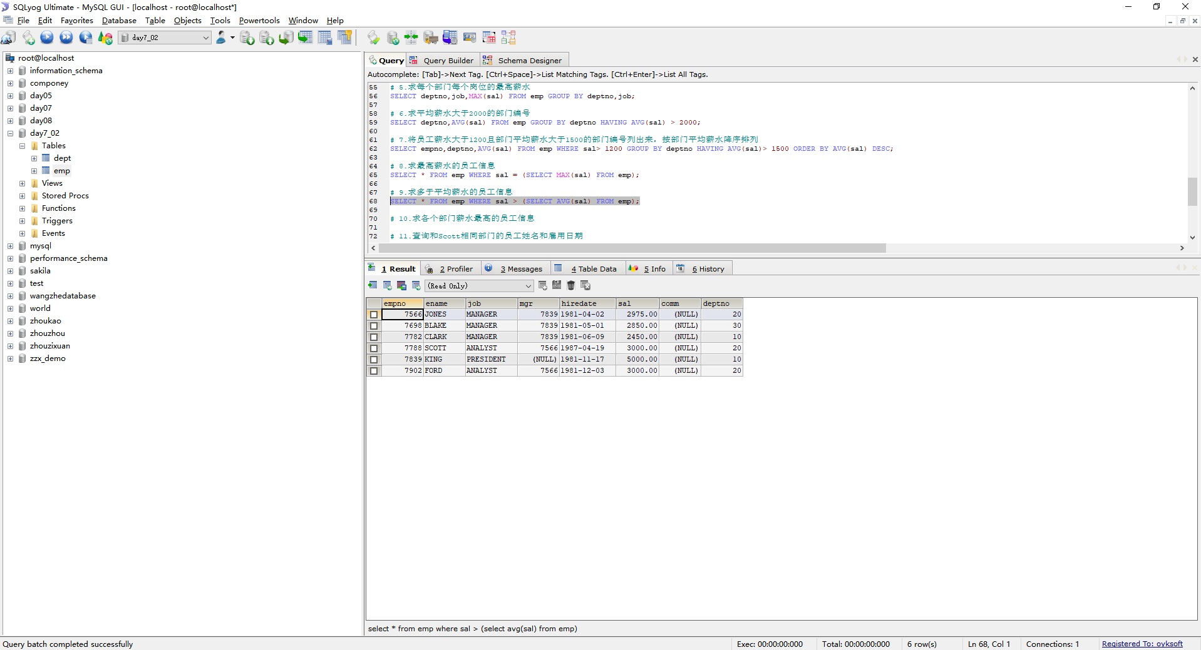

# 10.求各个部门薪水最高的员工信息

SELECT * FROM emp HAVING sal IN(SELECT MAX(sal) FROM emp GROUP BY deptno);

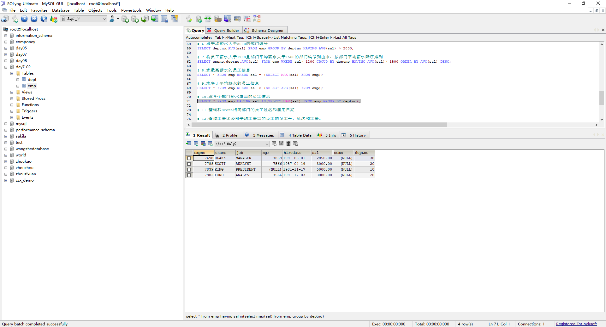

# 11.查询和Scott相同部门的员工姓名和雇用日期

SELECT ename,hiredate FROM emp WHERE deptno = (SELECT deptno FROM emp WHERE ename = 'Scott');

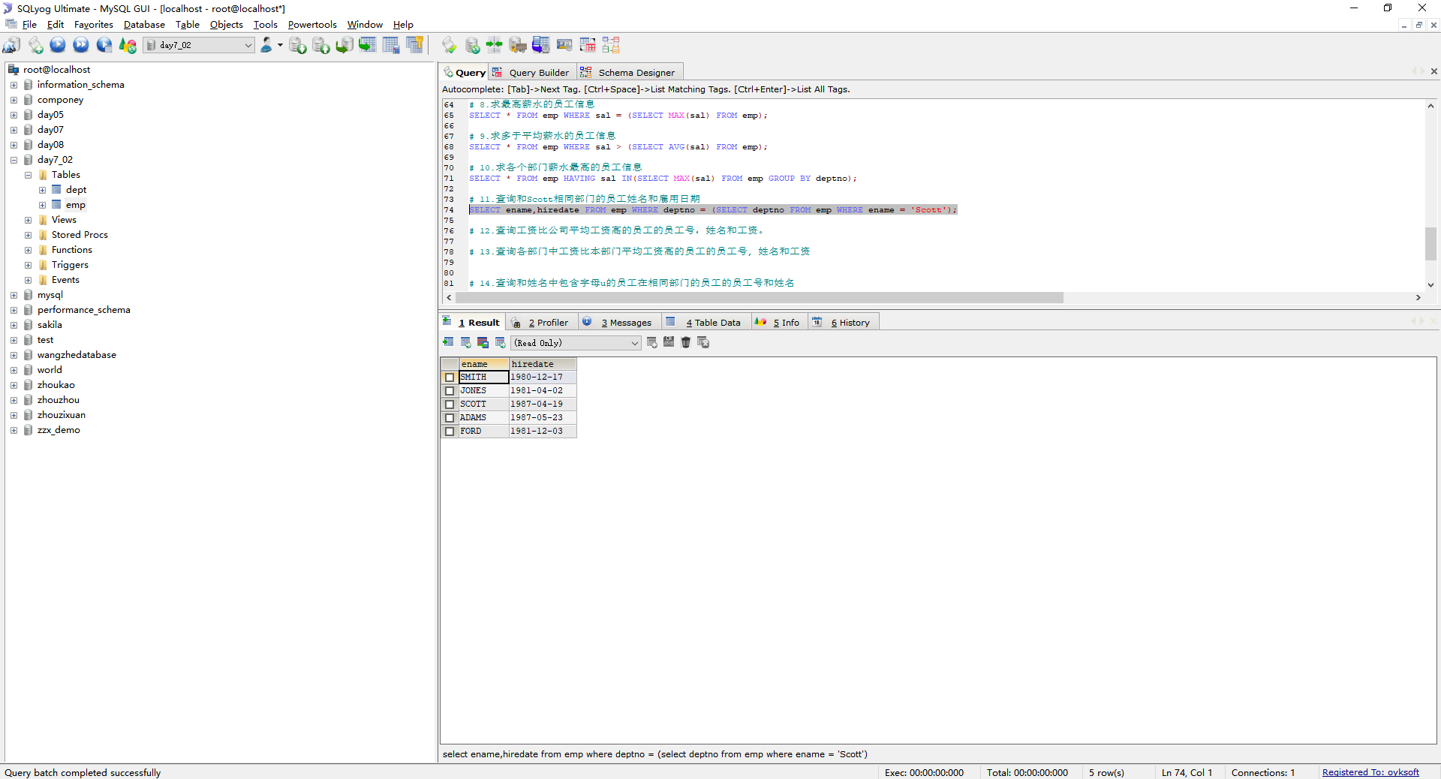

# 12.查询工资比公司平均工资高的员工的员工号，姓名和工资。

SELECT empno,ename,sal FROM emp WHERE sal > (SELECT AVG(sal) FROM emp);

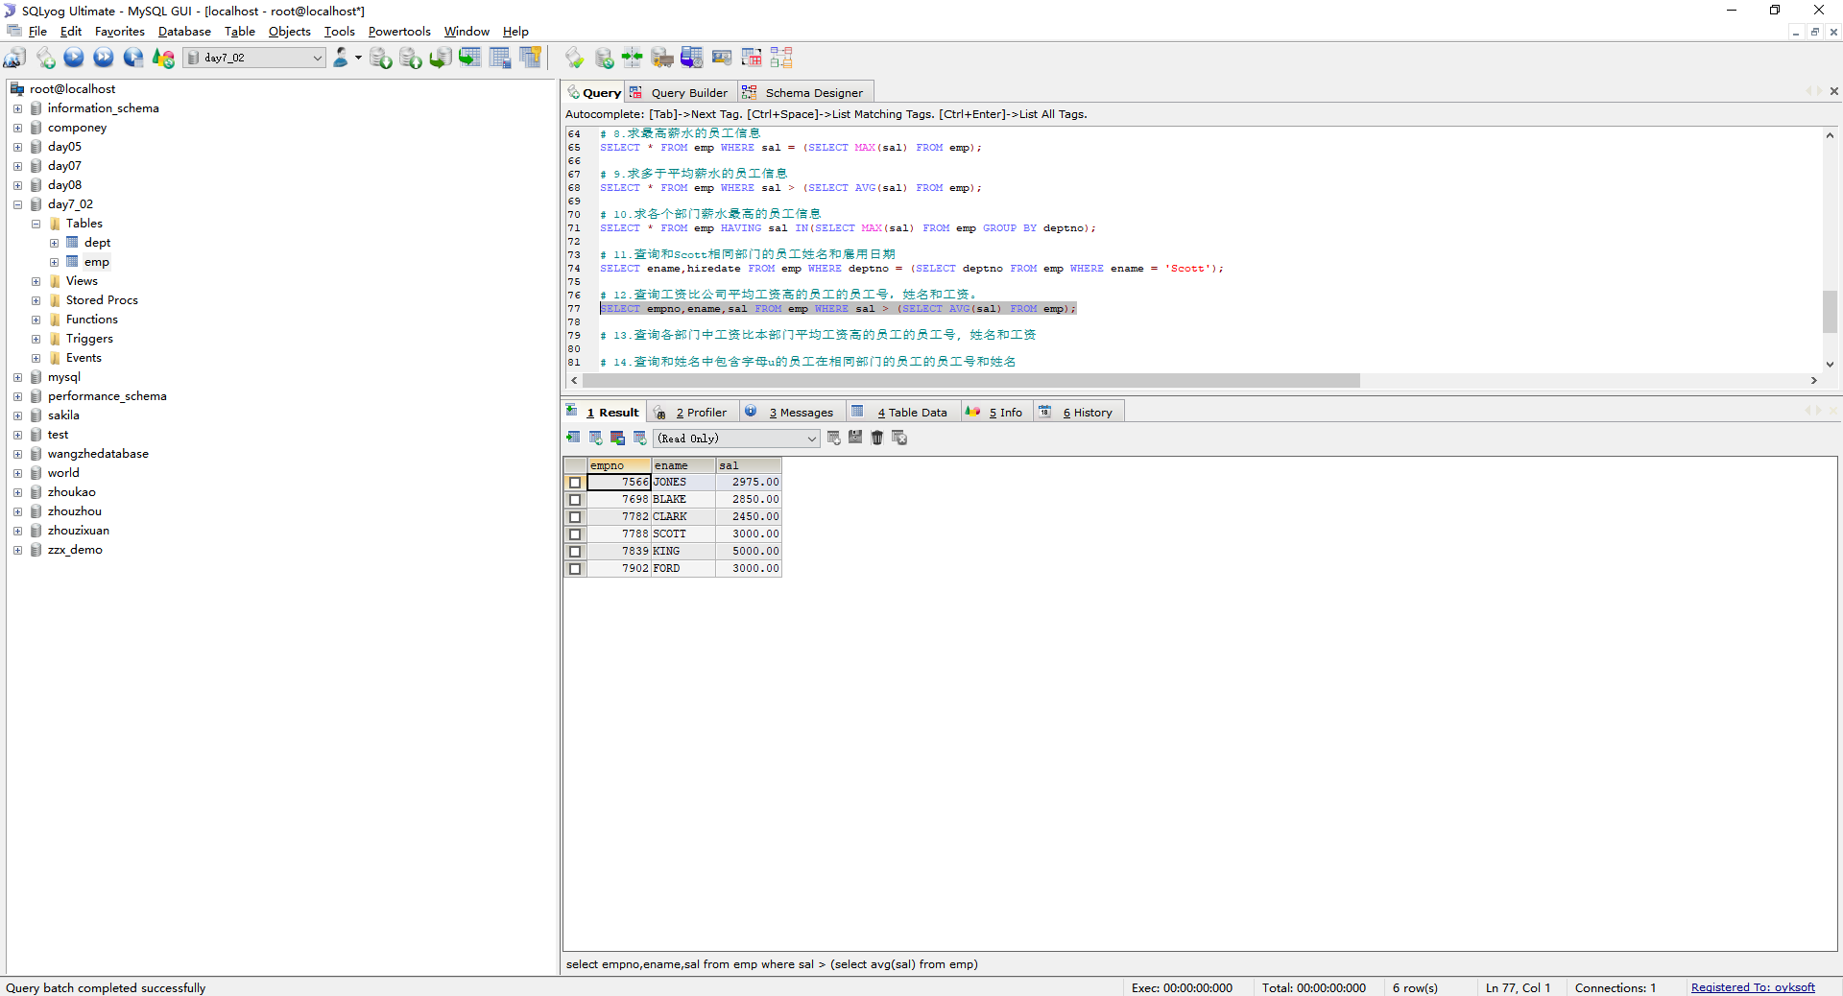

# 13.查询各部门中工资比本部门平均工资高的员工的员工号, 姓名和工资

SELECT emp.*,a.* FROM (SELECT deptno,AVG(sal) AS ag FROM emp GROUP BY deptno) AS a INNER JOIN emp ON a.deptno = emp.deptno WHERE emp.sal > a.ag;

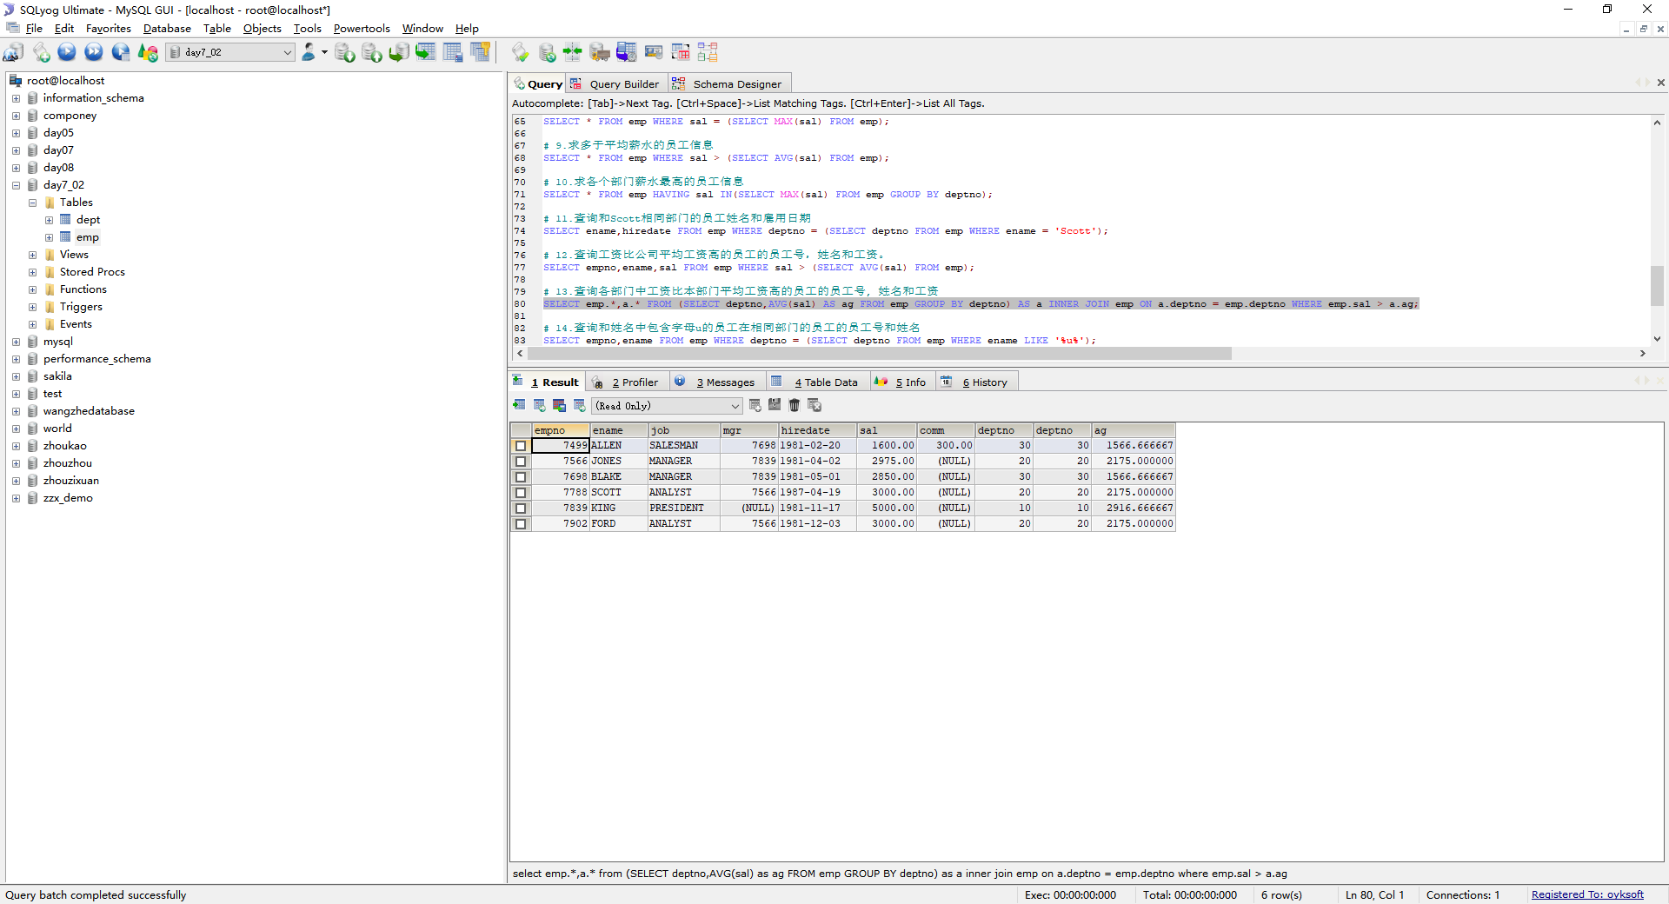

# 14.查询和姓名中包含字母u的员工在相同部门的员工的员工号和姓名

SELECT empno,ename FROM emp WHERE deptno = (SELECT deptno FROM emp WHERE ename LIKE '%u%');

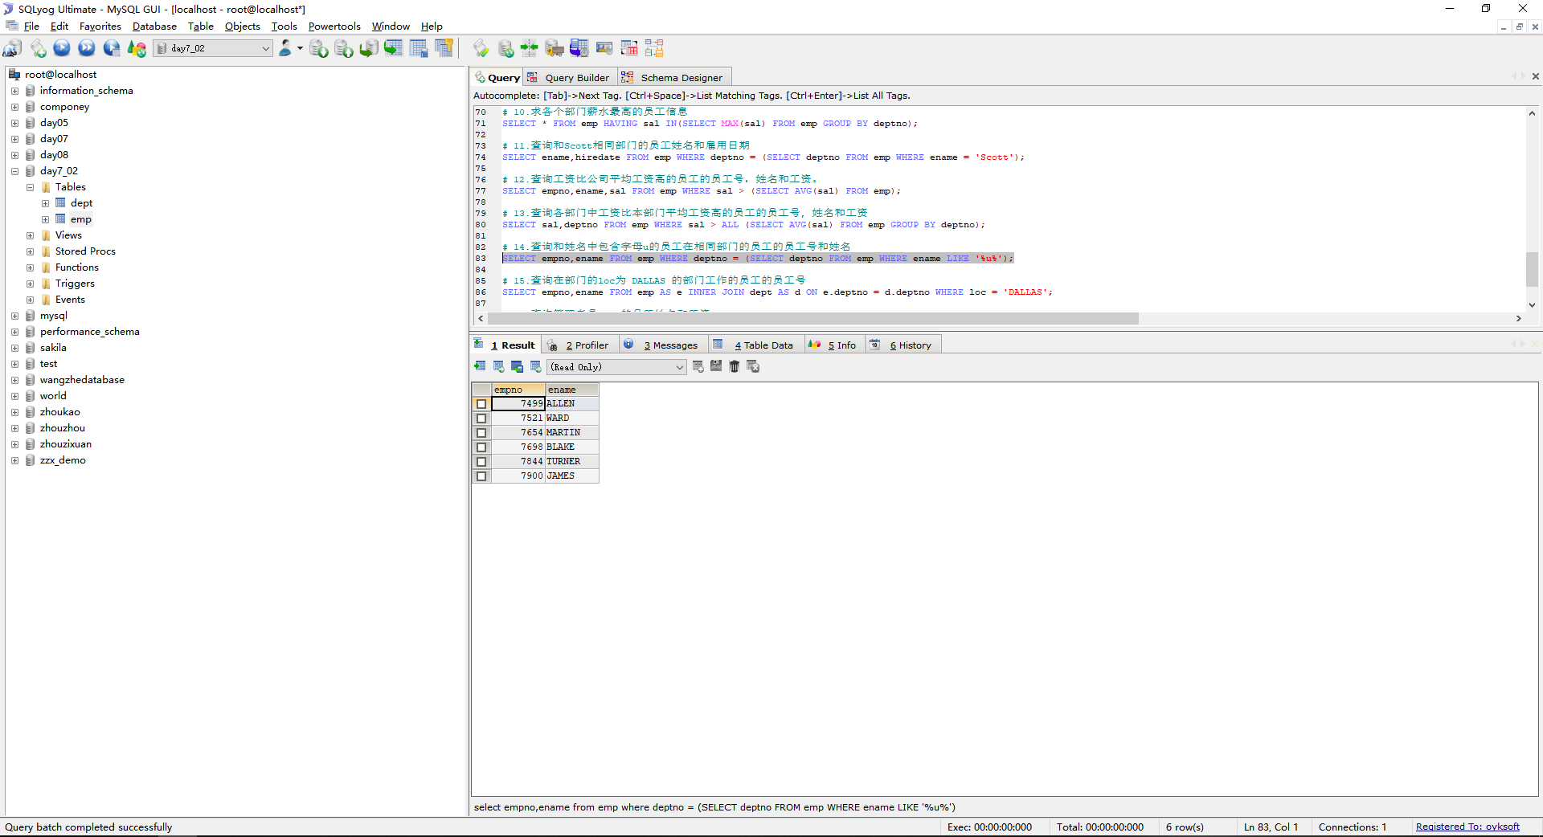

# 15.查询在部门的loc为 DALLAS 的部门工作的员工的员工号

SELECT empno,ename FROM emp AS e INNER JOIN dept AS d ON e.deptno = d.deptno WHERE loc = 'DALLAS';

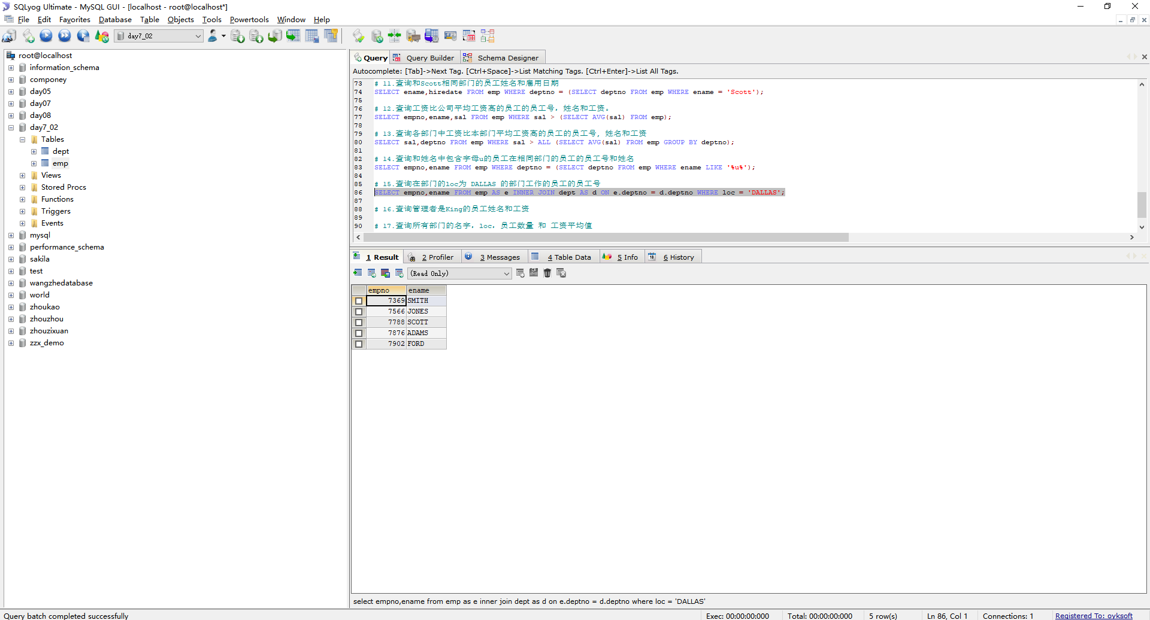

# 16.查询管理者是King的员工姓名和工资

SELECT ename,sal FROM emp WHERE mgr = (SELECT empno FROM emp WHERE ename = 'King');

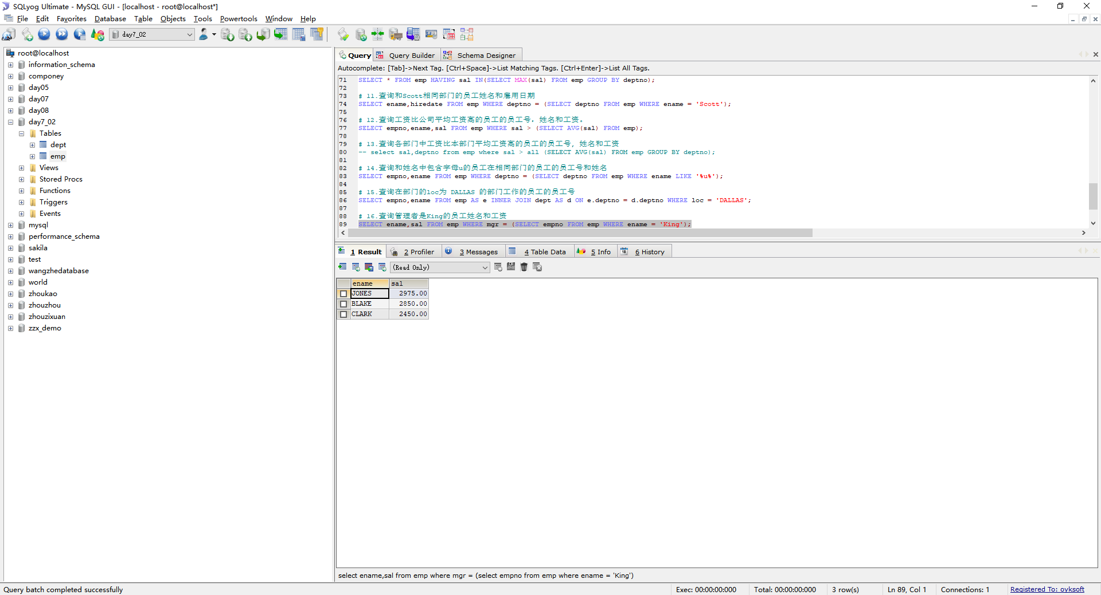

# 17.查询所有部门的名字，loc，员工数量 和 工资平均值

SELECT dname,loc,COUNT(*),AVG(sal) FROM emp AS e INNER JOIN dept AS d ON e.deptno = d.deptno GROUP BY dname;

